Connecting your PC, Monitors, and USB Devices

- The computer and items you’ve taken home should include your computer, your monitor, your keyboard, and your mouse. Below is a picture of how your connections should look once you’ve connected everything and the breakdown is as follows: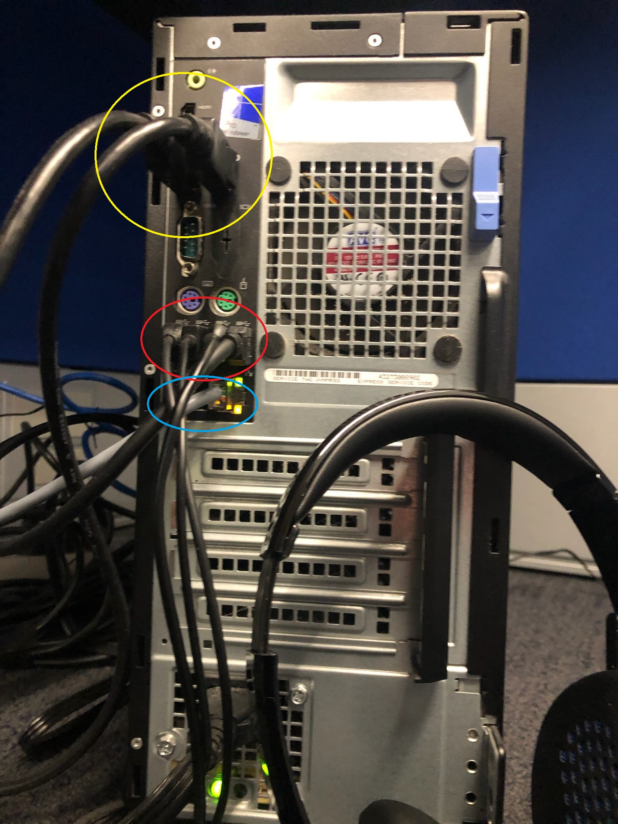
- Yellow Circle – These are the monitor cables, called DisplayPort. You will only have ONE of these and they are not to be confused with the HDMI connector all the way at the top. These go in a specific way, so when connecting, be careful and gentle when doing so.
- Red Circle – These are your USB connections. Here, you will plug in your keyboard, mouse, USB headset, and speaker bar (if your monitor has one, if not, ignore this portion).
- Blue Circle – This specifically, is the Ethernet connection for your computer, otherwise known as the “internet connection”. This cable will plug into your home modem or WiFi router (sometimes, they’re the same thing. This will be explained on another document).
- Your power cable is the final item and it’s all the way at the bottom. This will be plugged into a wall socket or power strip.

