Self-Service Network Password Reset Procedure

In any browser, got to https://idp.renhsc.com/passwordreset and type in your network user name (A domain (ddxx\) in front of a user name is not necessary). Then click submit.
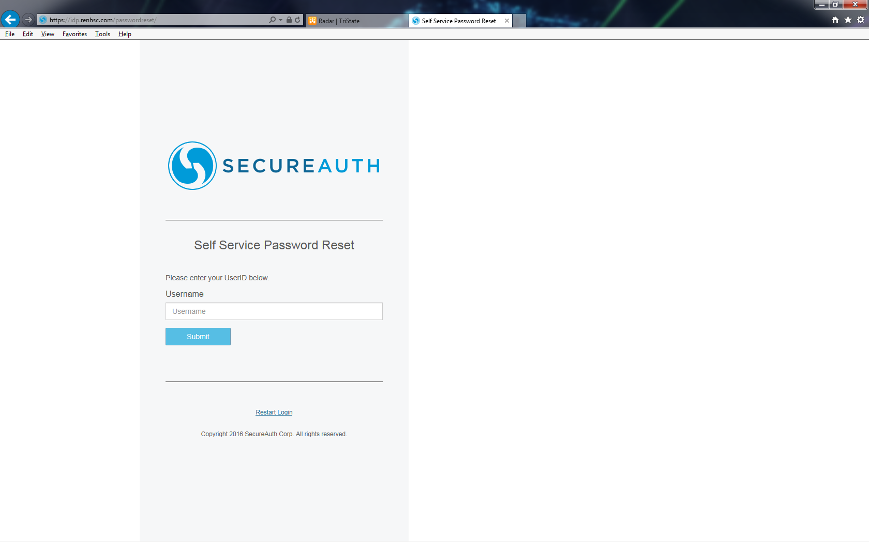

You will then be asked to choose a method to receive your registration code. Choose the option that works best for you, EXCEPT for contacting help desk, and click submit.
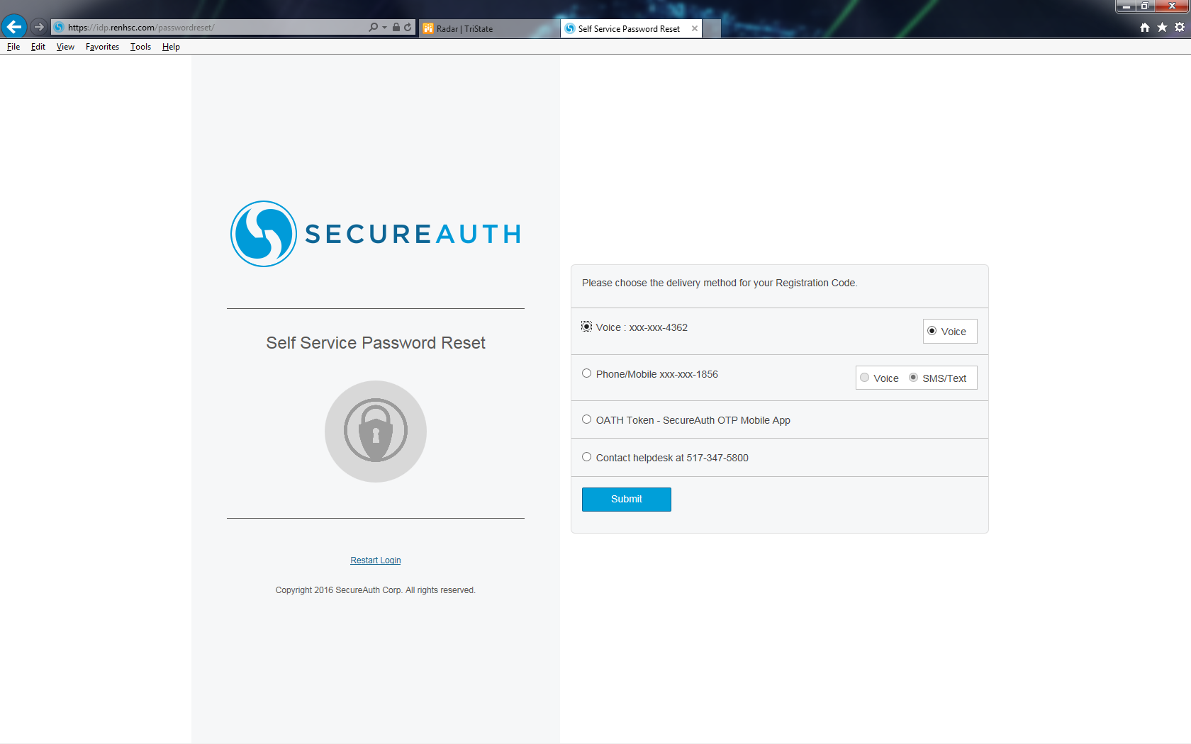

Enter the code that was sent to you and click submit.
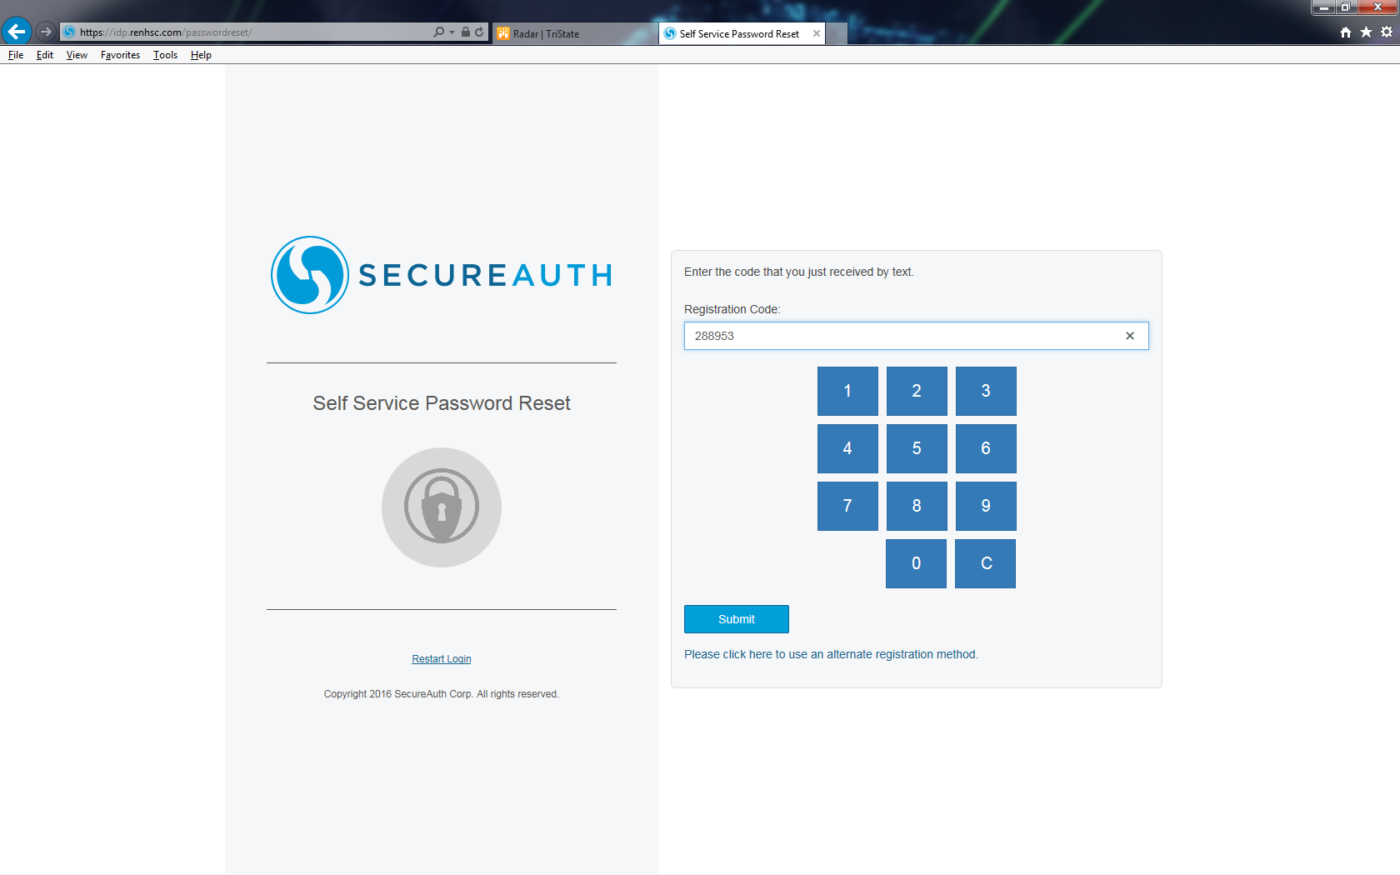

Enter your new password and click submit. Your network password should now be changed.
Note: You do not have to click restart login (doing so brings you back to the self-service reset page).
