VPN Connection Tutorial(Desktop)

- The VPN may show up automatically upon login into the computer. This is uncommon for new logins, but not impossible. However, in the event the VPN windows does NOT show up in the bottom right corner of the screen, you might find it in the system tray as shown in the below screen shot. 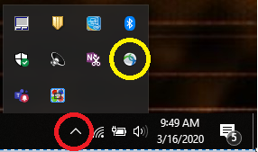
Click the upward arrow(red circled icon) to bring up the box above it. The yellow circled icon is the Cisco AnyConnect VPN icon. If this is there, proceed to step 3, if not, see step 2.
- 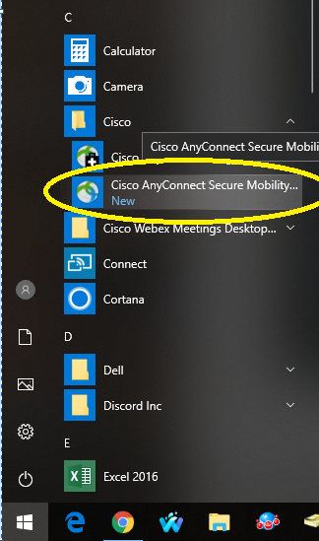In the even this icon does not display in the system tray, the application is simply not running. To start the application, click the start button at the bottom right of your screen with the Windows icon on it, navigate to the “C” section, and find the “Cisco” folder. Click the item labeled “Cisco AnyConnect Secure Mobility Client. The word Client is more than likely cut off, so click the icon WITHOUT the “+” sign on the icon. See the yellow circled icon below.

- Once launched, the below box should appear in the bottom right of your screen..
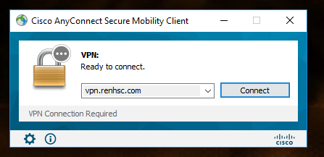For this step, enter “vpn.renhsc.com” as shown in the image below. Your field should be blank. If it has already been prefilled however with this address, simply click the “Connect” button.

- 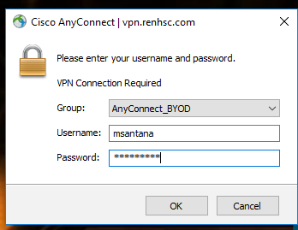The next box that shows up will have a dropdown menu and two fields to enter information. Ensure the “Group” is set to AnyConnect_BYOD. Enter your Windows username (such as “msantana”) in the “Username” field and your Windows password (the password you use to unlock your computer) and click “OK”. The connection to the VPN service will begin.

- The next box that appears will be the “MFA” portion, otherwise known as Multi-Factor Authentication. The options available in the screen shot may not be the options you have, but for this step, we won’t be entering ANY of those numbers. You will use your SecureAuth app and enter the EIGHT digits that appear on screen. This number is refreshed every thirty seconds and does NOT require an active internet connection, cellular or otherwise, to function.
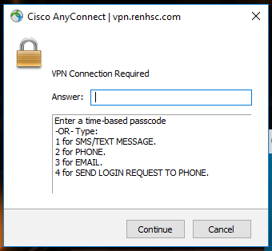WARNING: If you have not completed the “MFA Setup” tutorial, please click Cancel and do so. This setup portion is necessary before you will be able to continue.

  - 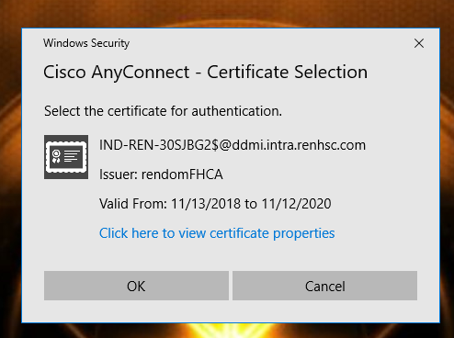Side note: If the below box pops up, simply click OK. NEVER click cancel.

- The below screen shot will appear next. Click “Accept” to continue.
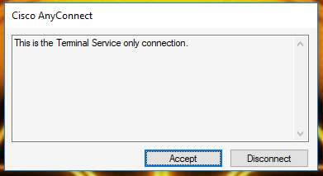The VPN client should now begin the connection and update of your software to most current, working version that Ren and DDMI are using. This involves a few changes that will take about 5-20 minutes depending on your home internet connection. If at any point the update process is interrupted, it will need to be restarted, though it will only restart the download and installation of modules that had failed.

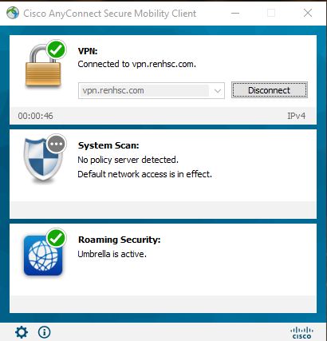
- When the system has fully updated, check your system tray(as shown in step 1) and double click the AnyConnect icon. If the software has successfully connected, your window should look like one of the following:
Either of these are correct. AT this point, click “Disconnect”.
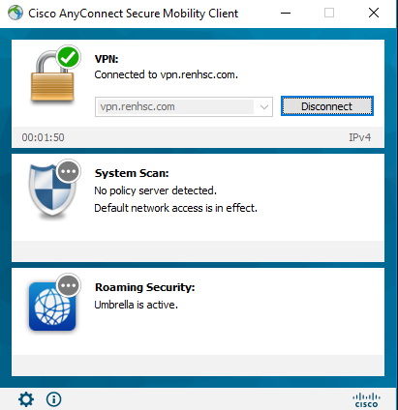

- Start the connection again as shown in step 3. When you reach step 4 again, change the group from “AnyConnect_BYOD” to “AnyConnect_Employee” and proceed with the connection as normal. There will be no further changes, though there is a chance there is an extra software update to be done, though this will be done automatically. When it’s all said and done, your AnyConnect window should look like the below screenshot.
NOTE: This whole process is done ONCE. Every connection that comes after this point will be quicker.

