**Cisco AnyConnect VPN Quick Guide – Personal Devices**

1. You MUST have a computer (Desktop, laptop, or VM) physically in the office to remote into for this to work
2. Go to <https://vpn.renhsc.com> and log in with your network username and password. You will be prompted to download and install the Cisco Anyconnect client. Installation instructions are available on this website.
3. Please try connecting to Cisco AnyConnect from your “start” menu and be sure to select “AnyConnect_BYOD” for the Group (Figure 2)
   1. Provide your network login username and password
   2. Provide 2 factor code when prompted from key fob or phone app
   3. Anyconnect will minimize once you’ve logged in. You’ll notice a yellow exclamation point year your system clock that says “No internet access” when you hover over it. This is intentional. When BYOD is active, you can ONLY remote into a Delta computer.

Figure : **Employee Profile** Figure 3: **Completed VPN Connection**

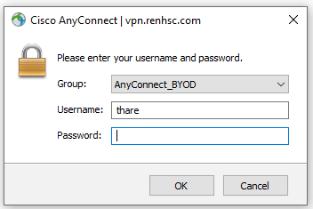

1. When AnyConnect establishes a successful connection, you will see something indicating “Network access allowed”
2. Go to your start button again and type “Remote Desktop” and click on Remote Desktop Connection. Enter the name of the computer you’re remoting into in the “Computer” field.
   1. If you have multiple monitors at home, before connecting click the “Show Options” button, then click the Display tab. Check the box to “Use all my monitors for the remote session. Click on the General tab again, and enter your computer name of your desktop that you’re remoting into.
   2. To find your computer name, check the top of your tower for a colored sticker. The computer name will be on that (Example: OKM-US-812H3G2). If you don’t have the sticker, you can contact the Technical Assistance Center and they can provide it to you.
3. Click “Connect” and enter your login information when requested.

If you need to reset your network password or unlock your account, you can do so by going to the website <https://idp.renhsc.com/passwordreset>

For any issues or troubleshooting, Contact the Technical Assistance Center at 517-347-5800